1. What OS and OS version are you using?

Windows 10 pro

10.0.17134 Build 17134

1. What is your CPU speed?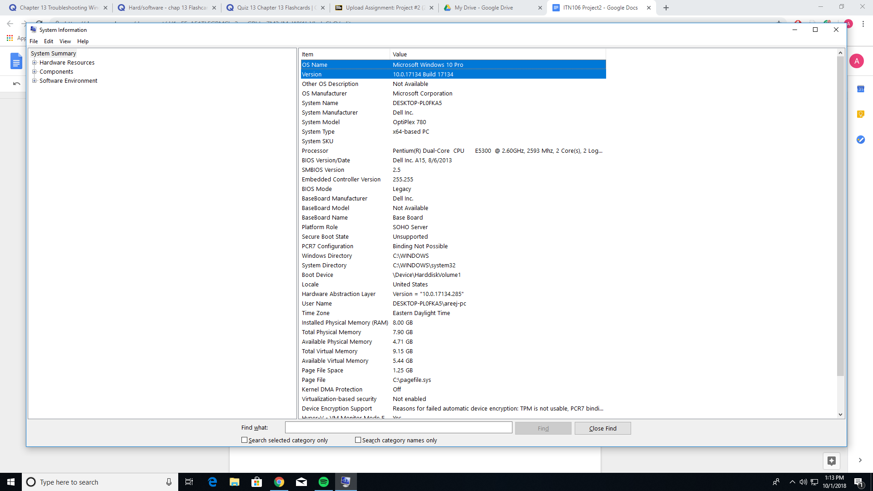

2.6GHz

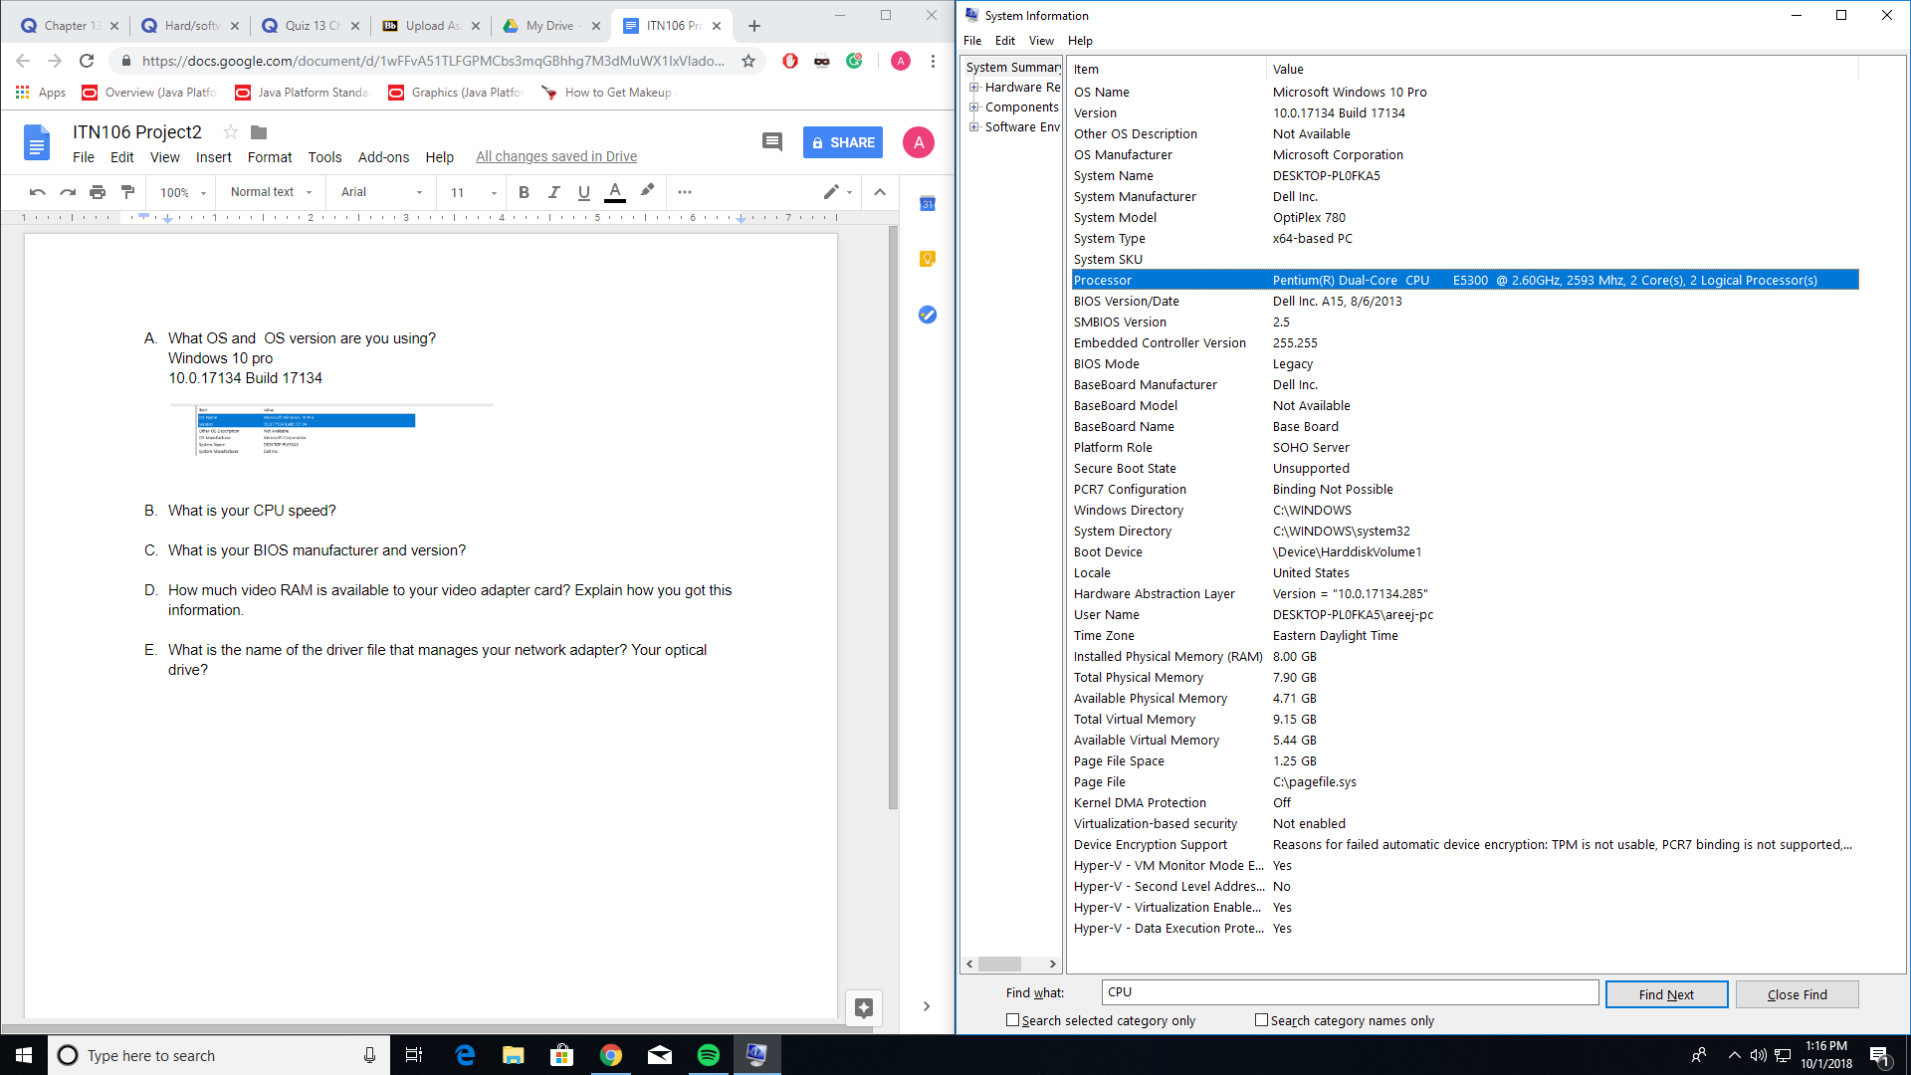

1. What is your BIOS manufacturer and version?

Dell Inc A15

2.5

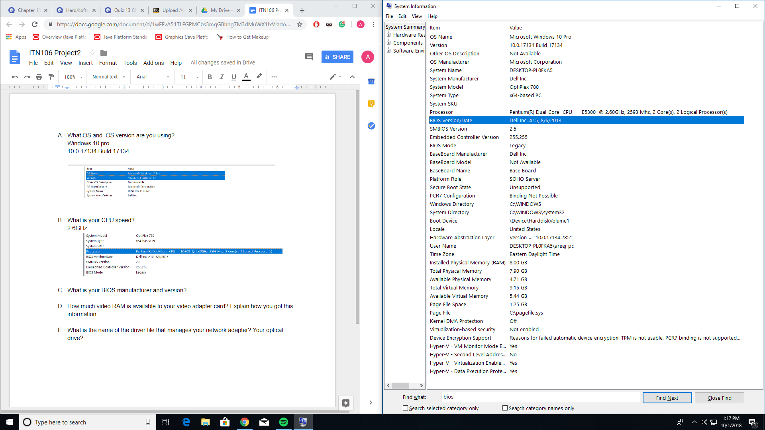

1. How much video RAM is available to your video adapter card? Explain how you got this information.

I have total graphics memory of 1695MB but dedicated to video memory is 64MB. I got this from going into display, going to advanced display setting then going into the properties for display 1.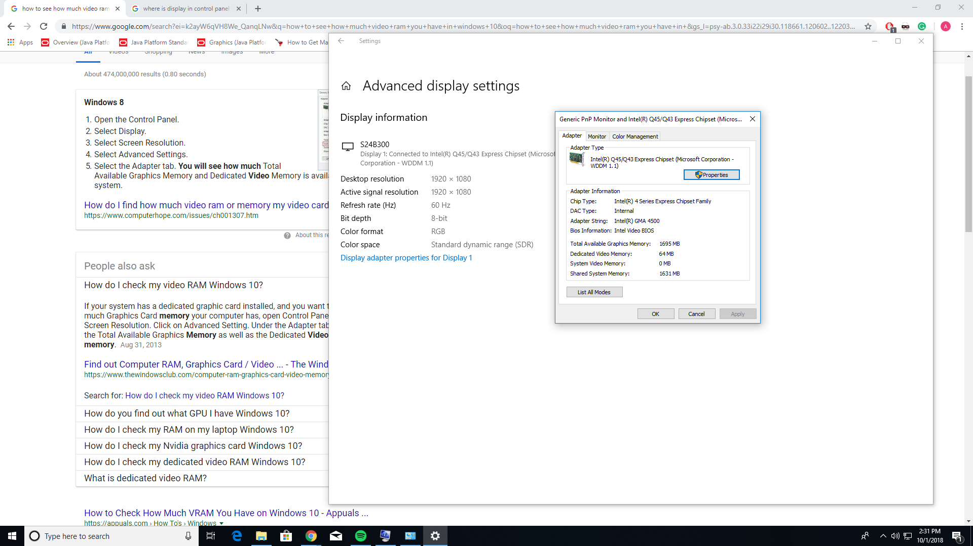

1. What is the name of the driver file that manages your network adapter? Your optical driver?

Intel(R) 82567LM-3 Gigabyte Network Connection

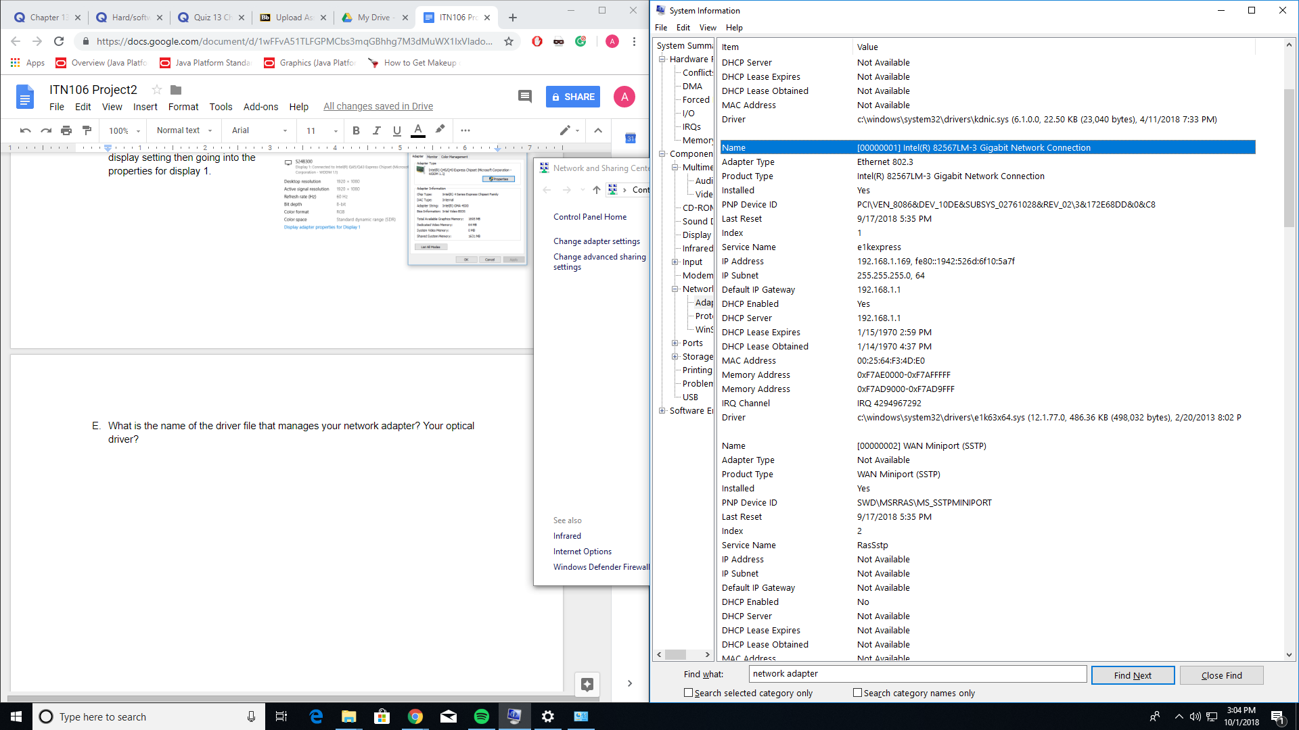

TEAc DVD-ROMDV-28SW

